**Impact of the Increased Tier 1 Capital Ratio Requirement on Return on Equity of Systemically Important Banks in Canada**

Jinghan Xu

**Abstract**

This study investigates the impact of the increase in Tier 1 Capital Ratio (T1CR) requirements from 4% to 6% under Basel III on Return on Equity (ROE) of Canadian systemically important banks (SIBs). Using a Difference-in-Differences (DiD) approach, 6 major Canadian SIBs are compared with 24 comparable U.S. SIBs between 2011 and 2017, where the new rule was fully implemented in 2014 in Canada but not in the U.S. until 2018. The results reveal a statistically significant negative causal relationship, which implies a tradeoff between resilience and profitability — while stricter capital requirements were developed to enhance financial stability, they may constrain bank performance in stable economic periods. Limitations arise from violating the parallel trend assumption, suggesting potential overestimation of the treatment effect. Nevertheless, this study contributes valuable insights into the ongoing global transition from Basel III to Basel IV, offering empirical evidence on how increased capital requirements shape bank profitability in a heavily regulated and early adopting financial system.

**Acknowledgements**

I would like to express my sincere gratitude to Professor Terry Moon whose guidance and insightful feedback were instrumental throughout the development of this paper.

**Introduction**

*Research question*

The Basel Accords are a series of international agreements developed by the Basel Committee on Banking Supervision (BCBS) to regulate banks and financial institutions globally. They aim to ensure banks’ sufficient capital reserves that absorb potential losses, and to prevent systemic risk within the financial system. In response to the 2007- 2008 financial crisis, Basel III was developed upon Basel II, and one of the changes is level up Tier 1 Capital Ratio (T1CR) requirement from 4% to 6%. T1CR is defined as the ratio of Tier 1 Capital (T1C) to Risk-Weighted Assets (RWA). T1C comprises two components. The first is Common Equity Tier 1 (CET1), which is the highest quality capital in the banking system, including common stock and retained earnings (Bank for International Settlements [BIS], n.d.). The second is Additional Tier 1 Capital (AT1), which is designed to absorb losses on a going-concern basis, such as perpetual contingent convertible capital instruments (BIS, n.d.). Risk-Weighted Assets (RWA) is used to assess the overall risk of a bank's assets.

In this study, I check the impact of this policy change in Canadian bank performance. More specifically, I investigate what is the effect of the increased T1CR requirement from 4% under Basel II to 6% under Basel III on Return on Equity (ROE) of SIBs in Canada.

*Motivation*

This study is motivated from 3 aspects. First of all, the study focuses on the Canadian SIBs because they acted resilient during Financial Crisis and recovered quickly compared to many other countries. Meanwhile, as a heavily regulated nation, Canada has been an early adopter of Basel IV ([Regnology](https://www.regnology.net/en/resources/insights/basel-iv-a-jurisdictional-breakdown/), n.d.), and it started to report the revised data since late 2024. As many other countries delayed the adoption of Basel Accord, it’s worthwhile to study the impacts in Canada as a reference to the rest of the world.

Secondly, there is the ongoing global transition from Basel III to Basel Reform (IV) nowadays, but there is inadequate data to support relevant empirical studies on Basel IV as of today, since the expected implementation date is January 2023, which is still earlier than the actual date in many countries. However, future research studying the adoption of Basel IV need a solid foundation, so it is also essential to empirically assess the impact of the previous Basel III policy. Therefore, this study also supports future investigations into Basel IV in Canada.

Lastly, many studies have shown that stricter capital rules increase banks' equity and decrease lending activities, which reduces risk-weighted assets. Both actions reduce ROE among financial institutions. Nevertheless, Nasdaq Insight (n.d.) also states that many banks face significant capital shortfalls and lower ROE due to increased capital requirements. However, there is a lack of studies discussing the relation of T1CR on ROE specifically, so this study examines whether the same theory holds in Canada.

*Literature Review*

Wagster (2012) compares the capital positions of Canadian banks during the Great Depression to the Basel III capital requirements. He found that Canadian banks with higher capital ratios were more resilient during the depression, highlighting the importance of capital buffers. However, Oyetade, Obalade, and Muzindutsi (2023) examined the performance of commercial banks in Africa after the adoption of Basel IV. They find that Basel IV's stricter capital rules improved bank stability but had mixed effects on profitability, implying the trade-off between resilience and returns in emerging markets. Similar research was also carried out among banks in the UK and Australia from 2000 to 2019 by Le, Nasir, and Huynh (2023). This study finds that stricter capital ratios do not significantly improve bank profitability or efficiency, highlighting the importance of an optimal capital structure and macroeconomics.

*Contributions*

There is a lack of study examining the effects of this specific rule, higher T1CR requirement in Basel III, in Canada. To address this gap, this research uses Canadian SIBs as a treatment group, compared to the control group of US SIBs which implemented this policy change later than the Canadian counterparts.  
*Empirical Strategy & Data*

To find the causal relation between higher T1CR and ROE of Canadian SIBs, the Difference-in-Difference (DiD) model with time and bank fixed effects is applied. It also involves bank-specific features and macroeconomic indicators. Data is from Bloomberg terminal and the World Bank database.

*Economic Interpretations & Policy Implications*

A statistically significant negative causal relationship is revealed — Canadian banks experienced an average decrease of 2.516 percentage points in ROE following the policy change, relative to U.S. SIBs. These findings highlight a key tradeoff between resilience and profitability: while stricter capital requirements enhance financial stability, they may constrain bank performance in stable economic periods.

**Institutional Setting**

The increased T1CR requirement from 4% to 6% was first introduced in 2010 as one of the updates from Basel II to Basel III. It was in response to the weaknesses of the banking system revealed during the global financial crisis, aiming to prevent future crises and ensuring a more resilient banking system. All the financial institutions worldwide are required to follow this accord, but the implementation timelines in each country vary based on their capability to for example, raise their T1C. Higher T1CR demonstrates higher ability to withstand financial stress and remain solvent. However, too high a ratio is anticipated to hurt the profitability and growth potential of a bank, limiting ROE. Thus, the regulators were convinced higher T1CR requirement can be a more efficient balance between safety and profitability.

SIBs include Global Systemically Important Banks (G-SIBs) and Domestic Systemically Important Banks (D-SIBs). According to the BCBS, G-SIBs are the top 40 banks worldwide considering their size, interconnectedness, substitutability, complexity, and cross-jurisdictional activity. Any distress or failure of these G-SIBs would disrupt the global financial market and lead to significant damage to global economy. Similarly, D-SIBs are the banks whose failure can lead to significant disruption nationally.

The treatment group consists of 6 Canadian G-SIBs and D-SIBs and the control group consists of 24 G-SIBs and D-SIBs in the United States (see the appendix for the list). The rise of T1CR Requirement was not fully implemented in the US until 2014, which is 4 years after the Canadian banks fully adopted the new rules. This delay makes US banks a comparable baseline. Thus, the data in this study is collected from 2011 to 2017, with the first quarter of 2011 to the fourth quarter of 2013 as the pre-policy change period, and the first quarter of 2014 to the fourth quarter of 2017 as the post-policy change period.

**Empirical Strategy**

*Economic model*

$${ROE}_{it}= β₀ + β₁{TP}_{it} + β₂T_{it} + β₃P_{it} + β₄{LeverageRatio}_{it} + β₅A{djustedEBITDA}_{it} + β₆{MarketCap}_{it} + β₇{StockPrice}_{it} + β₈{T1C_B }_{it}+ β₉{GDP}_{it} + β₁₀{CPI}_{it} + β₁₁{RIR}_{it} + α_{i} + δ_{t} + ε_{it}$$

A Difference-in-Differences (DiD) regression framework is applied. The subscripts `i` and `t` represent bank i at time t. Bank profitability is measured by Return on Equity (ROE), defined as the ratio of net income and Shareholders’ Equity. Higher ROE indicates more efficient management of banks’ assets and liabilities to generate earnings.

The key variables of interest include T, P and TP. T=0 if the data is collected before Q1 2014, while T=1 if the data is collected after the policy change since Q1 2014. Similarly, P=0 for US banks in the control group while P=1 for the treated Canadian banks. TP is an interaction term of T and P, representing treated and post-treatment periods, which allows identification of the differential impact on treated banks relative to control banks over time.

There are 8 control variables in the model, 5 measures bank-level financial conditions and 3 describe the national economy development in Canada and the US. T1C_B is Tier 1 capital in billions, and the leverage ratio quantifies the reliance on debt to fund operations and asset purchases in banks. Adjusted EBITDA is a bank’s earnings before interest, taxes, depreciation, and amortization. Market capitalization (market cap) is the value of a company's outstanding shares of stock. These 2 variables are also in billions. The macro indicators, including real gross domestic product (GDP) in USD, inflation level using 2010 as the base year (CPI), and 3-month real interest rate (RIR) are the rest of the inputs which capture broader macroeconomic influences across the treaty group and the baseline.

αi absorbs the bank fixed effects to eliminate bias from time-invariant unobserved heterogeneity across banks. δt absorbs time fixed effects, which control for all common shocks that affect all banks in the dataset at the same point in time. Standard errors are clustered at the bank level (εit), because the observations are repeated over time for each bank in the panel data, and the error terms within each bank are likely correlated across time; if ignoring this intra-bank correlation and use standard errors that assume independent observations, the model will underestimate the true variability of the estimated coefficients. Thus, to ensure the robustness of the analysis, clustered error is necessary.

*Assumptions*

The Difference-in-Differences (DiD) estimator relies on the parallel trends assumption: before the implementation of the new regulation in Canada, the return on equity (ROE) of Canadian banks should have followed a similar trend to that of US banks unaffected by the policy change in the control group. Only under this condition can the DiD estimator unbiased.

**Data Sources**

This study considers both macroeconomic factors and bank-wise features. The annual macroeconomic factors are from the databases hosted by the World Bank, extracted through an R package called “WDI”. The bank-wise data is collected through the Bloomberg Terminal, which integrates all the financial reports of banks in this study. To maximize the precision of the study, I collect the quarterly financial data as it is the most granular available information. The data from these two sources forms a 983 X 10 panel data, with 30 individual banks in 28 quarters between the start of 2011 and the end of 2017. However, some data are missing for some banks in a certain period. The summary statistics is on the right.

**Results**

*Model Assessment*

At a 0.01 significance level, the model returns an extremely small P-value of the F-test (0.000), so we have 99% confidence to reject the null hypothesis and conclude that at least one variable in the model is statistically significant. Additionally, the R-squared of 0.869 suggests that most of the variation in ROE can be explained by the model. Meanwhile, the Root Mean Squared Error (RMSE) of 2.558 is reasonably small, further validating the reliability of this model and demonstrating a strong fit.

*Key Parameters*

The line graph on the left supports a causal relationship, as the confidence level remains around zero prior to 2014, indicating no significant difference between the groups. However, following 2014, the confidence level begins to deviate, suggesting a potential impact of the policy change. The statistical summary table below shows that at the 0.01 significance level, the DID estimator (TP) of -2.516 is statistically significant, so we can reject the null hypothesis and conclude a robust negative causal impact of the increased T1CR requirement on ROE. More specifically, after the policy change, the ROE among Canadian SIBs, on average, decreased by 2.516 percentage points compared to the US SIBs. Furthermore, the coefficients of Leverage Ratio and adjusted EBITDA are estimated to be 0.613 and 0.727, respectively, both of which are statistically significant. This suggests that each 1 percentage point increase in the Leverage Ratio is associated with a 0.613 percentage point increase in the mean ROE, and each 1 billion increases in the adjusted EBITDA is associated with a 0.727 percentage point increase in the mean ROE. By contrast, neither banks’ market capitalization, the stock price, nor the Tier 1 Capital shows any statistically significant impact on ROE. Among the macroeconomic indicators, only CPI has a statistically significant estimator of 2.220 rather than GDP or RIR, meaning on average, an increase of 1 point on the CPI index leads to an estimated 2.220 percentage point increase in ROE.

**Interpretations**

The negative causal relation between a rise in T1CR requirement and the bank performance aligns with the findings by Le, Nasir, and Huynh, who stated that at the significant level of 1%, ROE drops 1 percentage point due to a Capital Ratio rise of 0.87 % in Australia. However, this change is smaller than what we find in this study. This may be because Canadian banks traditionally operate with higher leverage, so even small changes in capital ratios can have a larger impact on their ROE because their equity is relatively smaller compared to their assets.

*Bias*

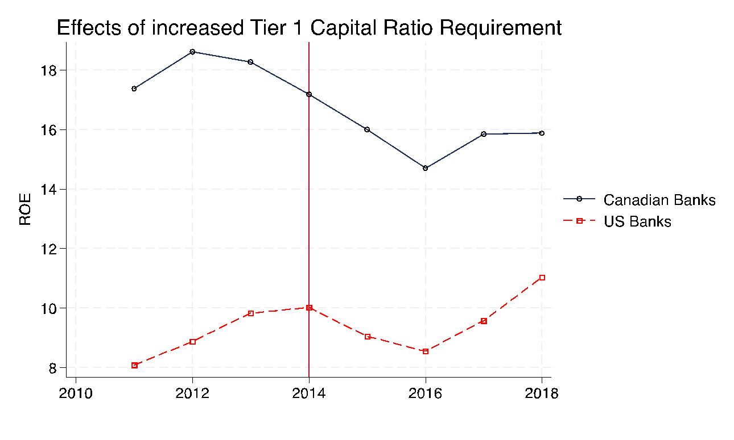The hold of the parallel trend assumption in the DiD framework strengthens the impact of the policy change on the bank’s performance rather than other external factors. However, according to the graph on the right, we see a violation of the parallel trend assumption in this study. This indicates that, even in the absence of the policy change, we cannot assume that such 2 groups would have reacted in the same way. More specifically, the pre-policy trends between the two groups are in opposite directions —the mean ROE among Canadian SIBs decreased, but it increased among US SIBs. This could lead to an overestimation of the negative impact of the increased T1CR requirement on ROE, presenting doubt on the reliability of this DiD model.

The opposite trends before 2014 can be explained by the main reversion theory, which suggests that over time the mean ROE among the US SIBs will increase back toward its historical norm as before the financial crisis. The main motivator can be that US banks are still in the recovery process from the financial crisis after 2008. Since the crisis was triggered by the failure among US financial institutions, it has deteriorated the US SIBs more than Canadian SIBs. Later, it took US banks more years to recover, and from 2011 on, their performance has been getting better, which leads to an increasing ROE. In contrast, since the Canadian SIBs show resilience, the aftermath of the financial crisis is milder and thus, the downward pre-policy trend in Canada can be because of a normal economic move. 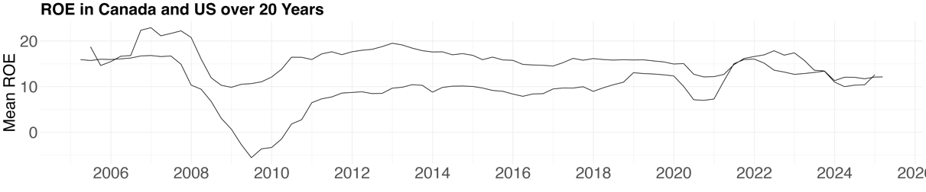

**Policy Implication**

The negative causal relation between the increased T1CR requirement and the ROE of banks in Canada SIBs suggests a tradeoff between profitability and resilience of the banking system in Canada. Even though the 2% increase was developed to raise banks’ capital buffer and to prevent future crises, which ultimately controls the losses against future shocks, it sacrifices banks’ performance during normal economic conditions. Therefore, it is crucial to identify a regulatory capital threshold that provides adequate protection without excessively constraining banks’ ability to generate returns for shareholders, considering market dynamics, macroeconomic trends, and financial innovation

It's noticeable that before the higher T1CR requirement was imposed, the Canadian SIBs already kept their T1CR above the new regulatory threshold. The mean T1C has been increasing from 2011 to 2017, and after the policy change, the mean T1CR rose again from 11% to 12.95%, further above the required level, addressing the more conservative operations among Canadian financial institutions.

While Basel III focused on the quantity and quality of capital, Basel IV tightens risk-weighted asset (RWA) calculations. In short, it raises the minimum level of capital banks hold against riskier assets and enhances the comparability and credibility of bank capital ratios across jurisdictions. This may further affect ROE, and it’s worth it to further study the effect once enough data is available.

*Limitations*

2014 cannot be seen as an exact cutoff of the policy change since the updates of the Basel Accords were first proposed in 2010. Any policy implementation takes time, so Canadian banks must have started to work towards the new policy before 2014, similarly to the US. Therefore, the data may reflect the impact of increased capital requirements and stricter lending regulations, even though such effects are not theoretically expected.

**Conclusion**

The DiD framework reveals a negative causal effect of the increased T1CR requirement from 4% to 6% under Basel III — on average, the ROE of Canadian SIBs declined by approximately 2.516 percentage points following the policy change, relative to US SIBs. However, while the intention behind increasing capital requirements is to enhance financial system stability, this analysis highlights the potential cost of more conservative capital buffers, especially in a stable economy, and emphasizes finding a balanced point that sustains profitability while ensuring systemic safety. Nevertheless, the violation of the parallel trends assumption may result in an overestimation, potentially influenced by macroeconomic recovery dynamics unique to each country. Ultimately, this analysis contributes to the ongoing debate about the cost-benefit balance of banking regulations and calls for dynamic, data-driven adjustments to capital adequacy standards that reflect both market realities and long-term financial stability goals.

**Reference**

Wagster, J.D. (2012) ‘Canadian bank capital during the Great Depression of the 1930s: A comparison to the Basel III requirements’, *Journal of Banking Regulation*, 13(2), pp. 89–98.

Oyetade, D., Obalade, A.A. and Muzindutsi, P.F. (2023) ‘Basel IV capital requirements and the performance of commercial banks in Africa’, *Journal of Banking Regulation*, 24, pp. 1–14. Available at: <https://doi.org/10.1057/s41261-021-00181-1>.

Le, T.N.L., Nasir, M.A. and Huynh, T.L.D. (2023) ‘Capital requirements and banks performance under Basel-III: A comparative analysis of Australian and British banks’, *The Quarterly Review of Economics and Finance*, 87, pp. 146–157. Available at: <https://doi.org/10.1016/j.qref.2020.06.001>.

Nasdaq. (2023). *Canadian go-live of Basel IV BCAR*. [online] Available at: <https://www.nasdaq.com/articles/fintech/regulatory-news/reg-news-canadian-go-live-of-basel-iv-bcar-2023>.

Regnology. (n.d.). *Basel IV: A jurisdictional breakdown*. [online] Available at: <https://www.regnology.net/en/resources/insights/basel-iv-a-jurisdictional-breakdown/>.

Investopedia. (n.d.). *Capital Adequacy Ratio (CAR)*. [online] Available at: <https://www.investopedia.com/terms/c/capitaladequacyratio.asp>.

Bank for International Settlements. (n.d.). *Definition of capital – Basel III*. <https://www.bis.org/fsi/fsisummaries/defcap_b3.pdf>

Investopedia. (n.d.). *Tier 1 Capital Ratio: What It Is, How It Works, Formula*. <https://www.investopedia.com/terms/t/tier-1-capital-ratio.asp>

Office of the Superintendent of Financial Institutions. (2023). *Capital Adequacy Requirements (CAR) 2024 – Chapter 2*. <https://www.osfi-bsif.gc.ca/sites/default/files/2023-12/car24_chpt2.pdf>

**Appendix**

2 Canadian G-SIBs are Royal Bank of Canada (RBC, ry), Toronto-Dominion Bank (TD, td).

4 Canadian D-SIBs are Bank of Montreal (BMO, bmo) and Bank of Nova Scotia (Scotiabank, bns), Canadian Imperial Bank of Commerce (CIBC, cm) and National Bank of Canada (,nbc).

8 US G-SIBs are JP Morgan, Citigroup, Bank of America, Goldman Sachs, Morgan Stanley, Wells Fargo, BNY Mellon and State Street

16 US D-SIBs are U.S. Bancorp (usb), Truist Financial (tfc), SunTrust Banks, Regions Financial (rf), Fifth Third Bank (fitb), Capital One Financial (cof), American Express (axp), Ally Financial (ally), Zions (zion), Santander Holdings USA (sov), RBS Citizens Financial Group (cfg), Northern Trust (ntrs), M&T Bank (mtb), Huntington Bancshares (hban), Discover Financial Services (dfs) and Comerica (cma)